PROJECT TITLE

BUCKET LIST

Name: Sita Ganesh College: SVIT, Secunderabad Course: B. Tech Branch: CSM

Problem Statement: Online Course Reservation System

Project Title: Bucket list learning

Category: Cloud Application Development

Skills required/Sofware requirements:

HTML, CSS, JavaScript, MongoDB, Bootstrap, Flask-Python Integration

**Project Description:**

It is a web-based application by using this website you can search for best courses online across various platforms like Coursera, EDX, MIT-opencourseware, Havard's-CS50, Udemy and etc. with help of this website user can save their time in searching courses across the web

In this website users can also fnd course rating, review and topics covered by that particular course they can also enroll in the courses they are interested in.

Users can also make a wish-list of courses in which they are interested in.

**Technical Architecture:**

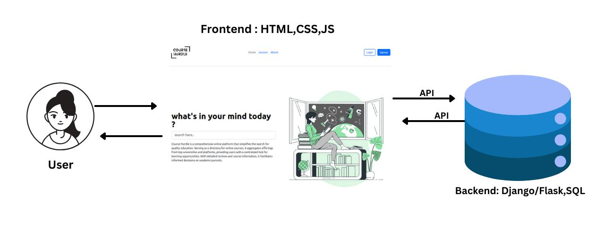

**Flow Chart:**

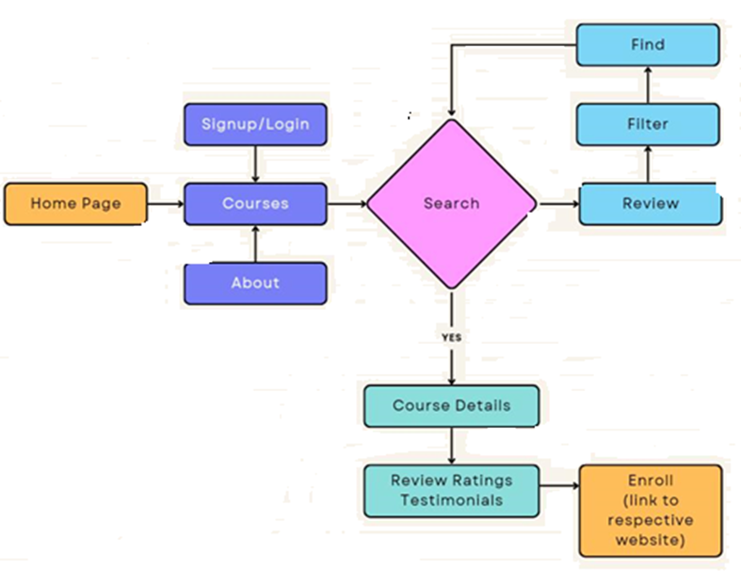

**Sofware Requirements Specifcation (SRS) Document:**

**1. Introduction**

**1.1 Purpose**

The purpose of this document is to outline the requirements for the development of the Bucket list learning website, aiming to provide a comprehensive and user-friendly platform for course discovery and enrollment.

**1.2 Scope**

The Bucket list learning website will serve as a centralized hub for users to explore, compare, and enroll in online courses from various providers. It will include features such as course search, user profles, reviews, and a recommendation system.

**2. System Overview**

**2.1 System Description**

The Bucket list learning website will be a web-based application accessible through standard web browsers. It will leverage a robust database to store course information, user data, and reviews. The system will provide an intuitive interface for users to interact with course content and make informed decisions.

**2.2 System Architecture**

The system will be built on a three-tier architecture: presentation layer, application layer, and data layer. It will utilize modern web technologies, including HTML, CSS, JavaScript, and a backend framework (e.g., Django or Ruby on Rails).

**3. Functional Requirements**

**3.1 User Registration and Authentication**

* Users should be able to create accounts.
* Users must authenticate securely to access personalized features.

**3.2 Course Search and Discovery**

* Users should be able to search for courses based on various criteria (e.g., subject, provider, ratings).
* The system should provide a recommendation engine for personalized course suggestions

**3.3 Course Information**

* Detailed course information, including descriptions, prerequisites, and provider details, should be displayed.
* Users should have the option to leave reviews and ratings for courses.

**3.4 User Profile**

* Users should be able to create and update their profiles.
* The system should track and display a user's course history, reviews, and preferences.

**3.5 Enrollment and Progress Tracking**

* Users should be able to enroll in courses directly from the platform.
* The system should track and display a user's progress within enrolled courses.

**4. Non-Functional Requirements**

**4.1 Performance**

* The website should respond to user interactions within 2 seconds.
* The system should handle concurrent user requests without significant performance degradation.

**4.2 Security**

* User data, including personal information and passwords, must be stored securely.
* The system should implement proper authentication and authorization mechanisms.

**4.3 Usability**

* The user interface should be intuitive and accessible, catering to users with varying levels of technical proficiency.

The website should be responsive and compatible with different devices and screen sizes.

**5. Constraints**

**5.1 Technology Constraints**

* The system must be developed using compatible web technologies.
* The website should support common web browsers (e.g., Chrome, Firefox, Safari).

**6. Assumptions and Dependencies**

**6.1 Assumptions**

* Users have a reliable internet connection for accessing the website.
* Course providers will provide APIs or data feeds for course information.

**6.2 Dependencies**

* The development team relies on external APIs or data feeds for real-time course information.

**7. Conclusion**

This Software Requirements Specification serves as a guideline for the development of the Bucket list learning website. It outlines the functional and non-functional requirements, constraints, and dependencies to ensure the successful implementation of a robust and user-friendly online course platform.

**Design Engineering of Bucket list learning:**

Design engineering involves creating and developing products, systems, or solutions by applying engineering principles and design methodologies. It encompasses various disciplines, such as mechanical, electrical, and industrial engineering, to address challenges and create innovative solutions.

1. **Use-Case Diagram:**

A use case diagram in UML (Unified Modelling Language) is a graphical representation of the system's functionality and the interactions between users (actors) and the system. Here's a simplified example of a use case diagram for an online course reservation software system:

**1.1 Actors:**

* **Student:** Represents a user who wants to enroll in courses.
* **Admin**: Represents an administrator who manages the overall system.

1. **2 Use Cases:**
   * **View Course Catalog:**
     + **Actors**: Student, Instructor
     + **Description**: Users can view a catalog of available courses.
   * **Enroll in Course**:
     + **Actors**: Student
     + **Description**: Students can enroll in a course they are interested in.
   * **Create Course**:
     + **Actors**: Instructor
     + **Description**: Instructors can create new courses to be offered.
   1. **Relationships:**
      * **Generalization** : Represents an inheritance relationship, indicating that one actor or use case is a specialized version of another.
      * **Include**: Represents the inclusion of one use case within another.
      * **Extend**: This will help you to provide information or insights that align better with your preference.

Here is an representation of the use case diagram:

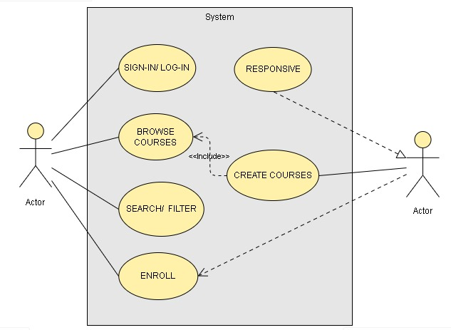

In this use case diagram, actors are represented as stick figures, and use cases are represented as ovals. The relationships between them illustrate how users interact with the system to perform specific actions. This is a simplified representation, and in a real-world scenario, you may have more actors, use cases, and relationships based on the specific features and requirements of your online course reservation software

**2. Class Diagram:**

A class diagram is a type of UML (Unifed Modeling Language) diagram that illustrates the structure and relationships of classes in a system. Below is a simplifed representation of class diagrams for an online course reservation software system. This system typically involves classes like User, Course, Reservation, and others.

**2.1 User Class:**

Attributes: User ID, Name, Email, Password

Methods: Login(), Logout(), Enroll()

**2.2 Course Class:**

Attributes: Title, Description, link.

method: search(), cards().

* 1. **About Class:**

Attributes: Description, vectors, paragraphs

Methods: about(), details()

**2.4 Enroll class:**

Attributes: checkbox, submit.

Method: details(), profile(),verification()

In the diagrams below::

1. ."+" denotes public access.

1. "-" denotes private access.
2. Attributes are usually denoted with a hyphen (-).
3. Methods are denoted with a plus sign (+).

These class diagrams provide a high-level view of the relationships between key classes in an online course reservation system. Depending on the specifc requirements and features of your software, you might need to expand or customize these diagrams further.

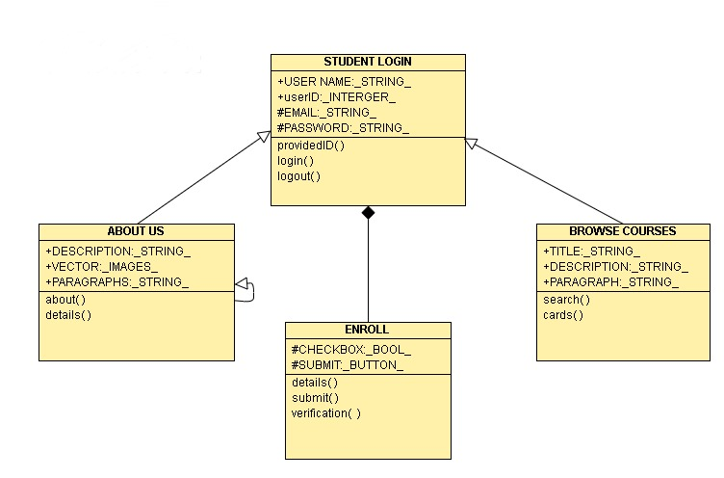

1. Activity Diagram :

Activity diagrams in UML (Unifed Modeling Language) depict the fow of activities within a system. Here's a simplifed example of an activity diagram for an online course reservation software system:

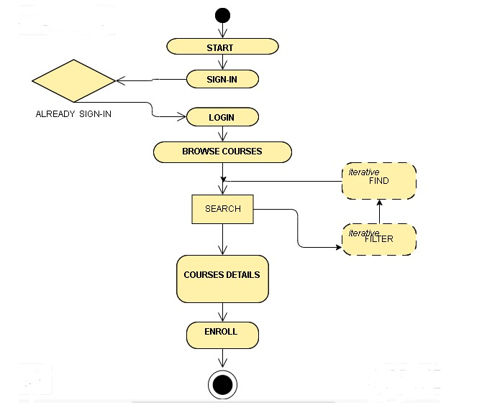

In this activity diagram:

* The process begins with the "User Requests Login Page" activity.
* The "User Login" activity involves authentication, ensuring the user's identity.
* After logging in, the user views the course catalog.
* The user selects a course and initiates the "Enroll in Course" activity.
* The system checks for admin approval in the "Confrm Enrollment Status" activity.
* The process ends.

This is a simplifed representation, and in a real-world scenario, you may have more activities, decision points, and parallel fows based on the specifc features and requirements of your online course reservation software.

**4. Sequence Diagram :**

A sequence diagram in UML (Unifed Modeling Language) illustrates the interactions between objects over time. Here's a simplifed example of a sequence diagram for an online course reservation software system, focusing on the process of a student enrolling in a course:

**4.1 Participants (Objects/Entities):**

* + Student: Represents the user wanting to enroll.
  + CourseCatalog: Manages the available courses.
  + Course: Represents a specific course.
  + Admin: adds courses

**4.2 Sequence of Interactions:**

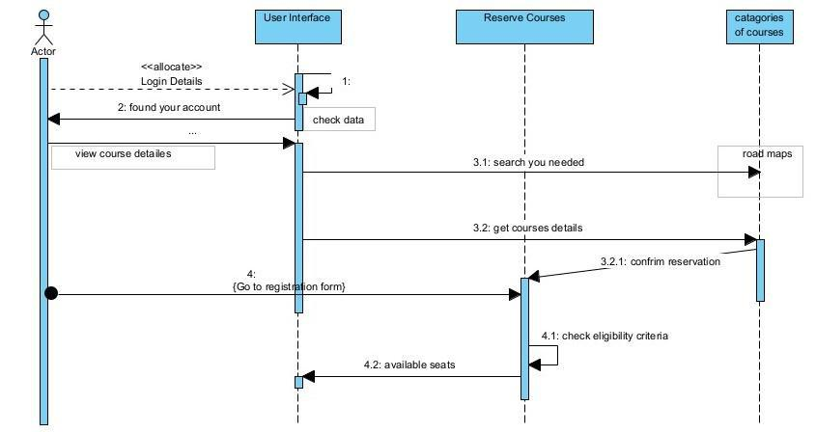

In this sequence diagram:

* Lifelines (vertical dashed lines) represent the diferent participants (objects/entities) involved.
* Arrows represent the flow of messages between participants.
* Numbers indicate the sequence of interactions.

**5. Deployment Diagram:**

A deployment diagram in Unified Modelling Language (UML) is used to model the physical deployment of software components within a system. It illustrates how software components are deployed on hardware nodes and how those nodes interact with each other. The primary purpose of a deployment diagram is to visualize the distribution of processing across a network and to show the configuration of run-time processing nodes

Explanation:

The "User Interface" interacts with the "Web Server" for user interactions.

The "Web Server" communicates with the "Application Server" to process requests.

The "Application Server" interacts with the "Database Server" to fetch or update data.

The "Database Server" stores and retrieves information related to course reservations.

Please note that this is a simplified representation, and in a real-world scenario, there could be additional components like load balancers, firewalls, and more detailed interactions between components.

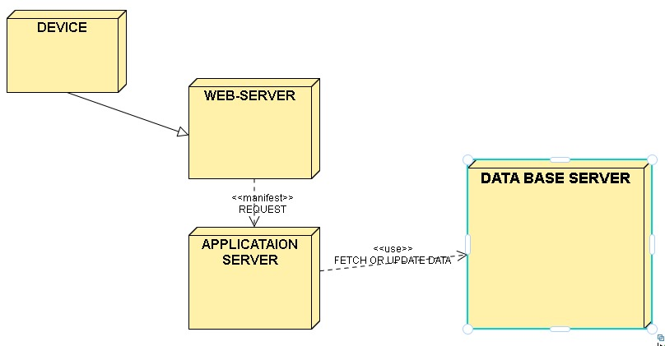

# Coding:

Home page Coding:-

Home Page:

<!DOCTYPE html>

<html lang="en">

<head>

  <meta charset="UTF-8">

  <meta name="viewport" content="width=device-width, initial-scale=1">

  <link rel="stylesheet" href="styles/styles.css">

  <link href="https://cdn.jsdelivr.net/npm/bootstrap@5.3.2/dist/css/bootstrap.min.css" rel="stylesheet"

    integrity="sha384-T3c6CoIi6uLrA9TneNEoa7RxnatzjcDSCmG1MXxSR1GAsXEV/Dwwykc2MPK8M2HN" crossorigin="anonymous">

  <link rel="stylesheet" href=" https://cdn.jsdelivr.net/npm/bootstrap@5.3.2/dist/css/bootstrap.min.css">

  <script src="https://cdn.jsdelivr.net/npm/@popperjs/core@2.11.8/dist/umd/popper.min.js"

    integrity="sha384-I7E8VVD/ismYTF4hNIPjVp/Zjvgyol6VFvRkX/vR+Vc4jQkC+hVqc2pM8ODewa9r"

    crossorigin="anonymous"></script>

  <script src="https://cdn.jsdelivr.net/npm/bootstrap@5.3.2/dist/js/bootstrap.min.js"

    integrity="sha384-BBtl+eGJRgqQAUMxJ7pMwbEyER4l1g+O15P+16Ep7Q9Q+zqX6gSbd85u4mG4QzX+"

    crossorigin="anonymous"></script>

  <link rel="stylesheet" href="https://fonts.googleapis.com/css2?family=Roboto:wght@400;700&display=swap">

  <title>Online Course Reservation</title>

</head>

<body>

  <header>

    <nav>

      <div class="list">

        <img src="images/logoBL.png" alt="image">

        <ul class="nav-ul">

          <li class="nav-li"><a href="index.html">Home</a></li>

          <li class="nav-li"><a href="about.html">About</a></li>

          <li class="nav-li"><a href="browsecourses.html">Browse Courses</a></li>

          <li class="nav-li"><a href="faq.html">FAQ</a></li>

        </ul>

      </div>

    </nav>

  </header>

  <main>

    <div class="container">

      <div class="text">

        <h1>

          Develop Your <span>Most

          Engaged Workforce.</span> Every Team. Everywhere.

        </h1>

        <button class="btn btn-dark btn-lg" type="button"><a href="signin.html">Sign UP</a></button>

        <button class="btn btn-dark btn-lg" type="button"><a href="login.html">Log In</a></button>

      </div>

      <div class="img2">

        <img class="im2" src="images/Programmer-bro.png" alt="img">

      </div>

    </div>

    <hr>

    <div class="search">

      <input type="text" class="search-input" name="" class="input">

      <button type="submit" class="search-button">Search</button>

    </div>

    <section id="features">

      <div class="row">

        <div class="feature-box col-lg-4 ">

          <i class="fa-solid fa-laptop fa-4x"></i>

          <svg xmlns="http://www.w3.org/2000/svg" height="35" width="35"

            viewBox="0 0 640 512"><!--!Font Awesome Free 6.5.1 by @fontawesome - https://fontawesome.com License - https://fontawesome.com/license/free Copyright 2023 Fonticons, Inc.-->

            <path

              d="M128 32C92.7 32 64 60.7 64 96V352h64V96H512V352h64V96c0-35.3-28.7-64-64-64H128zM19.2 384C8.6 384 0 392.6 0 403.2C0 445.6 34.4 480 76.8 480H563.2c42.4 0 76.8-34.4 76.8-76.8c0-10.6-8.6-19.2-19.2-19.2H19.2z" />

          </svg>

          <h3>Course Catalog</h3>

          <p>Display a catalog of available courses with detailed information </p>

        </div>

        <div class="feature-box col-lg-4 ">

          <i class="fa-solid fa-magnifying-glass fa-5x"></i>

          <svg xmlns="http://www.w3.org/2000/svg" height="35" width="35"

            viewBox="0 0 512 512"><!--!Font Awesome Free 6.5.1 by @fontawesome - https://fontawesome.com License - https://fontawesome.com/license/free Copyright 2023 Fonticons, Inc.-->

            <path

              d="M416 208c0 45.9-14.9 88.3-40 122.7L502.6 457.4c12.5 12.5 12.5 32.8 0 45.3s-32.8 12.5-45.3 0L330.7 376c-34.4 25.2-76.8 40-122.7 40C93.1 416 0 322.9 0 208S93.1 0 208 0S416 93.1 416 208zM208 352a144 144 0 1 0 0-288 144 144 0 1 0 0 288z" />

          </svg>

          <h3>Search and Filters:</h3>

          <p>Enable users to search for courses based on various criteria</p>

        </div>

        <div class="feature-box col-lg-4">

          <i class="fa-solid fa-registered fa-10x"></i>

          <svg xmlns="http://www.w3.org/2000/svg" height="35" width="35"

            viewBox="0 0 512 512"><!--!Font Awesome Free 6.5.1 by @fontawesome - https://fontawesome.com License - https://fontawesome.com/license/free Copyright 2023 Fonticons, Inc.-->

            <path

              d="M256 512A256 256 0 1 0 256 0a256 256 0 1 0 0 512zM160 152c0-13.3 10.7-24 24-24h88c44.2 0 80 35.8 80 80c0 28-14.4 52.7-36.3 67l34.1 75.1c5.5 12.1 .1 26.3-11.9 31.8s-26.3 .1-31.8-11.9L268.9 288H208v72c0 13.3-10.7 24-24 24s-24-10.7-24-24V264 152zm48 88h64c17.7 0 32-14.3 32-32s-14.3-32-32-32H208v64z" />

          </svg>

          <h3>Enrollment </h3>

          <p>Provide a mechanism for users to enroll in courses of their choice</p>

        </div>

        <div class="feature-box col-lg-4">

          <i class="fa-solid fa-user fa-10x"></i>

          <svg xmlns="http://www.w3.org/2000/svg" height="35" width="35"

            viewBox="0 0 448 512"><!--!Font Awesome Free 6.5.1 by @fontawesome - https://fontawesome.com License - https://fontawesome.com/license/free Copyright 2023 Fonticons, Inc.-->

            <path

              d="M224 256A128 128 0 1 0 224 0a128 128 0 1 0 0 256zm-45.7 48C79.8 304 0 383.8 0 482.3C0 498.7 13.3 512 29.7 512H418.3c16.4 0 29.7-13.3 29.7-29.7C448 383.8 368.2 304 269.7 304H178.3z" />

          </svg>

          <h3>User Profiles</h3>

          <p>Allow users to create and manage their profiles</p>

        </div>

        <div class="feature-box col-lg-4">

          <i class="fa-solid fa-universal-access fa-10x"></i>

          <svg xmlns="http://www.w3.org/2000/svg" height="35" width="35"

            viewBox="0 0 512 512"><!--!Font Awesome Free 6.5.1 by @fontawesome - https://fontawesome.com License - https://fontawesome.com/license/free Copyright 2023 Fonticons, Inc.-->

            <path

              d="M0 256a256 256 0 1 1 512 0A256 256 0 1 1 0 256zm161.5-86.1c-12.2-5.2-26.3 .4-31.5 12.6s.4 26.3 12.6 31.5l11.9 5.1c17.3 7.4 35.2 12.9 53.6 16.3v50.1c0 4.3-.7 8.6-2.1 12.6l-28.7 86.1c-4.2 12.6 2.6 26.2 15.2 30.4s26.2-2.6 30.4-15.2l24.4-73.2c1.3-3.8 4.8-6.4 8.8-6.4s7.6 2.6 8.8 6.4l24.4 73.2c4.2 12.6 17.8 19.4 30.4 15.2s19.4-17.8 15.2-30.4l-28.7-86.1c-1.4-4.1-2.1-8.3-2.1-12.6V235.5c18.4-3.5 36.3-8.9 53.6-16.3l11.9-5.1c12.2-5.2 17.8-19.3 12.6-31.5s-19.3-17.8-31.5-12.6L338.7 175c-26.1 11.2-54.2 17-82.7 17s-56.5-5.8-82.7-17l-11.9-5.1zM256 160a40 40 0 1 0 0-80 40 40 0 1 0 0 80z" />

          </svg>

          <h3>Accessibility</h3>

          <p>Ensure that the platform is accessible to users with disabilities</p>

        </div>

        <div class="feature-box col-lg-4">

          <i class="fa-solid fa-shield fa-10x"></i>

          <svg xmlns="http://www.w3.org/2000/svg" height="35" width="35"

            viewBox="0 0 512 512"><!--!Font Awesome Free 6.5.1 by @fontawesome - https://fontawesome.com License - https://fontawesome.com/license/free Copyright 2023 Fonticons, Inc.-->

            <path

              d="M256 0c4.6 0 9.2 1 13.4 2.9L457.7 82.8c22 9.3 38.4 31 38.3 57.2c-.5 99.2-41.3 280.7-213.6 363.2c-16.7 8-36.1 8-52.8 0C57.3 420.7 16.5 239.2 16 140c-.1-26.2 16.3-47.9 38.3-57.2L242.7 2.9C246.8 1 251.4 0 256 0z" />

          </svg>

          <h3>Security and Data Privacy</h3>

          <p>Implement security measures to protect user data and ensure compliance with data privacy regulations</p>

        </div>

      </div>

    </section>

    <div class="companies">

    </div>

  </main>

  <footer>

    <div class="container1 footer">

      <h2 class="footer-h2">Join Us and Explore the world of learning</h2>

      <p class="footer-p text-center">Unlock new possibilities by enrolling in our diverse range of online courses.

        Connect with us on social media

        for the latest updates and promotions.</p>

      <hr>

      <p class="footer-p text-center">Thank you for checking out BucketList. I will give my best to make this BucketList

        platform as favourite place

        to find courses.</p><br>

      <div class="footer-links">

        <ul class="footer-ul">

          <li class="footer-li"><a class="footer-a" href="index.html">Home</a></li>

          <li class="footer-li"><a class="footer-a" href="about.html">About</a></li>

          <li class="footer-li"><a class="footer-a" href="browsecourses.html">Browse Courses</a></li>

        </ul>

      </div>

    </div>

  </footer>

</body>

</html>

About Page coding:

<!DOCTYPE html>

<html lang="en">

<head>

    <meta charset="UTF-8">

    <meta name="viewport" content="width=device-width, initial-scale=1.0">

    <link rel="stylesheet" href="styles/about.css">

    <title>About</title>

    <link href="https://cdn.jsdelivr.net/npm/bootstrap@5.3.2/dist/css/bootstrap.min.css" rel="stylesheet"

        integrity="sha384-T3c6CoIi6uLrA9TneNEoa7RxnatzjcDSCmG1MXxSR1GAsXEV/Dwwykc2MPK8M2HN" crossorigin="anonymous">

</head>

<body>

    <header>

        <nav>

            <div class="list">

                <img src="images/logoBL.png" alt="image">

                <ul class="header-ul">

                    <li class="header-li"><a class="header-a" href="index.html">Home</a></li>

                    <li class="header-li"><a class="header-a" href="about.html">About</a></li>

                    <li class="header-li"><a class="header-a" href="browsecourses.html">Browse Courses</a></li>

                    <li class="header-li"><a class="header-a" href="faq.html">FAQ</a></li>

                </ul>

            </div>

        </nav>

    </header>

    <main>

        <div class="container">

            <div class="vectors">

            <img src="images/vector3.png" alt="" class="about-img">

            <img src="images/vector2.png" alt="" class="about-img2"></div>

            <h1>Welcome to Bucket List Learning!</h1>

            <p>Embark on a journey of continuous growth and discovery with Bucket List Learning. We are passionate about

                providing a platform that brings together learners and opportunities from across the web. Whether you're

                looking to master new skills, explore diverse subjects, or stay updated on the latest trends, Bucket

                List Learning is your gateway to a world of knowledge</p>

            <hr>

            <p>Discover handpicked courses, curated just for you, and dive into a learning experience that fits your

                unique aspirations. Join our community of enthusiastic learners and turn your bucket list into a

                checklist of accomplishments. Your learning adventure starts here—let's make every moment count.</p>

        </div>

    </main>

    <div class="empty">

        <div class="container block">

            <div class="img">

                <img src="images/browse-course-pic.png" alt="">

            </div>

            <div class="text">

                <h2>Find top-notch training faster</h2>

                <p>Quickly search a catalog of more than 30,000 courses from world class publishers on a variety of

                    topics

                    and industries.</p>

            </div>

        </div>

    </div>

    <section>

        <div class="container">

            <h2>What Matters to Us</h2>

            <p>Your Performance is the cruial Cosplay of Success</p>

            <p>Get followed with use</p>

            <div class="album py-5 bg-body-tertiary">

                <div class="container">

                    <div class="row row-cols-1 row-cols-sm-2 row-cols-md-3 g-3">

                        <div class="col">

                            <div class="card1 card  shadow-sm">

                                <div class="card-body">

                                    <img src="images/collaboration.png" alt="">

                                    <h3 class="card-title">Collaboration</h3>

                                    <p class="card-text">Shoulder-to-Shoulder we are here to support to give the

                                        best,and we wont get lagged to reach the best content to you.</p>

                                    <div class=" d-flex justify-content-between align-items-center"></div>

                                </div>

                            </div>

                        </div>

                        <div class="col">

                            <div class="card1 card  shadow-sm">

                                <div class="card-body">

                                    <img src="images/growth_1460537.png" alt="">

                                    <h3 class="card-title">Growth Mindset</h3>

                                    <p class="card-text">We are passionate learners and hold education in the highest

                                        regard.</p>

                                    <div class=" d-flex justify-content-between align-items-center"></div>

                                </div>

                            </div>

                        </div>

                        <div class="col">

                            <div class="card1 card  shadow-sm">

                                <div class="card-body">

                                    <img src="images/care.png" alt="">

                                    <h3 class="card-title">Care</h3>

                                    <p class="card-text">We always think about the terms of your persective, that leads

                                        a good understanding about what you needed.</p>

                                    <div class=" d-flex justify-content-between align-items-center"></div>

                                </div>

                            </div>

                        </div>

                    </div>

                </div>

            </div>

    </section>

    <footer>

        <div class="footer">

            <ul class="footer-ul">

                <Li class="footer-li"><a class="footer-a" href="index.html">Home</a></Li>

                <li class="footer-li"><a class="footer-a" href="about.html">About</a></Li>

                <li class="footer-li"><a class="footer-a" href="browsecourses.html">Browse Course</a></li>

                <li class="footer-li"><a class="footer-a" href="faq.html">FAQ</a></li>

            </ul>

        </div>

    </footer>

</body>

</html>

Login page coding:

<!DOCTYPE html>

<html lang="en">

<head>

    <meta charset="UTF-8">

    <meta name="viewport" content="width=device-width, initial-scale=1.0">

    <link rel="stylesheet" href="styles/login.css">

    <link rel="stylesheet" href="   https://cdn.jsdelivr.net/npm/bootstrap@5.3.2/dist/css/bootstrap.min.css">

    <title>Login</title>

</head>

<body>

    <div class="container ">

        <img src="images/logoBL.png" alt="BucketList logo">

        <form action="">

            <div class="icon">

                <i class="fa-solid fa-key fa-blue"></i>

                <svg xmlns="http://www.w3.org/2000/svg" height="25" width="25"

                    viewBox="0 0 512 512"><!--!Font Awesome Free 6.5.1 by @fontawesome - https://fontawesome.com License - https://fontawesome.com/license/free Copyright 2023 Fonticons, Inc.-->

                    <path

                        d="M336 352c97.2 0 176-78.8 176-176S433.2 0 336 0S160 78.8 160 176c0 18.7 2.9 36.8 8.3 53.7L7 391c-4.5 4.5-7 10.6-7 17v80c0 13.3 10.7 24 24 24h80c13.3 0 24-10.7 24-24V448h40c13.3 0 24-10.7 24-24V384h40c6.4 0 12.5-2.5 17-7l33.3-33.3c16.9 5.4 35 8.3 53.7 8.3zM376 96a40 40 0 1 1 0 80 40 40 0 1 1 0-80z" />

                </svg>

            </div>

            <h3>Log In</h3>

            <hr>

            <div class="mb-3">

                <label for="email" class="form-label">Email address</label>

                <input type="email" class="form-control" id="email">

            </div>

            <div class="mb-3">

                <label for="password" class="form-label">Password</label>

                <input type="password" class="form-control" id="password">

            </div>

            <button type="submit" class="btn btn-57375D">Submit</button>

        </form>

        <P><a href="signin.html">Don't Have an Account? SignIn Now</a></P>

    </div>

    <footer>

        <div class="footer">

            <ul>

                <Li><a href="index.html">Home</a></Li>

                <li><a href="about.html">About</a></Li>

                <li><a href="browsecourses.html">Browse Course</a></li>

                <li><a href="faq.html">FAQ</a></li>

            </ul>

        </div>

    </footer>

</body>

</html>

# Testing strategies for Bucket List :

## Test cases :

### 1. unit testing

Unit testing focuses on verifying the functionality of individual components or modules in isolation. It ensures that each unit of the software performs as expected.

#### Home-page Unit Testing :

|  |  |  |  |
| --- | --- | --- | --- |
| **s.no** | **Test Description** | **Expected Result** | **Success** |
| 1. | test individual components on home page | components function correctly in isolation | Success |
| 2. | check functionality of the home page navigation | navigation between sections works as expected | success |

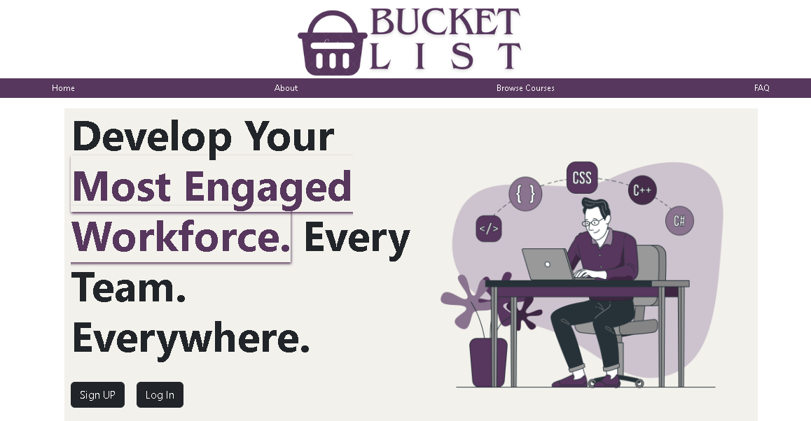

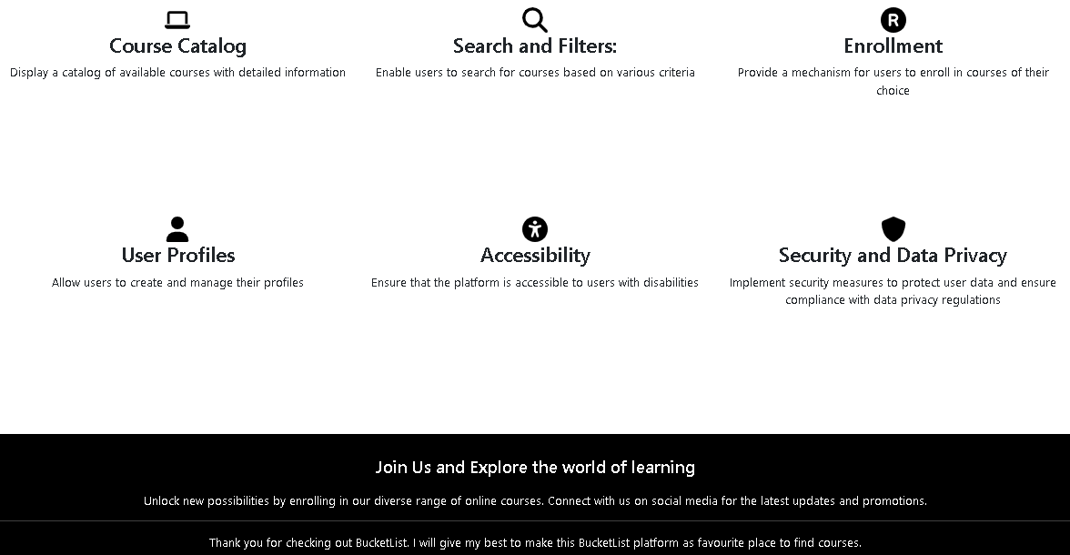

#### login-page Unit Testing :

|  |  |  |  |
| --- | --- | --- | --- |
| **s.no** | **Test Description** | **Expected Result** | **Success** |
| 1. | test the login form component | form components work correctly in isolation | success |
| 2. | check validation of user-name and password field | proper validation messages are displayed | success |
| 3. | test other third party sign-in options | proper validation and components work perfectly | success |

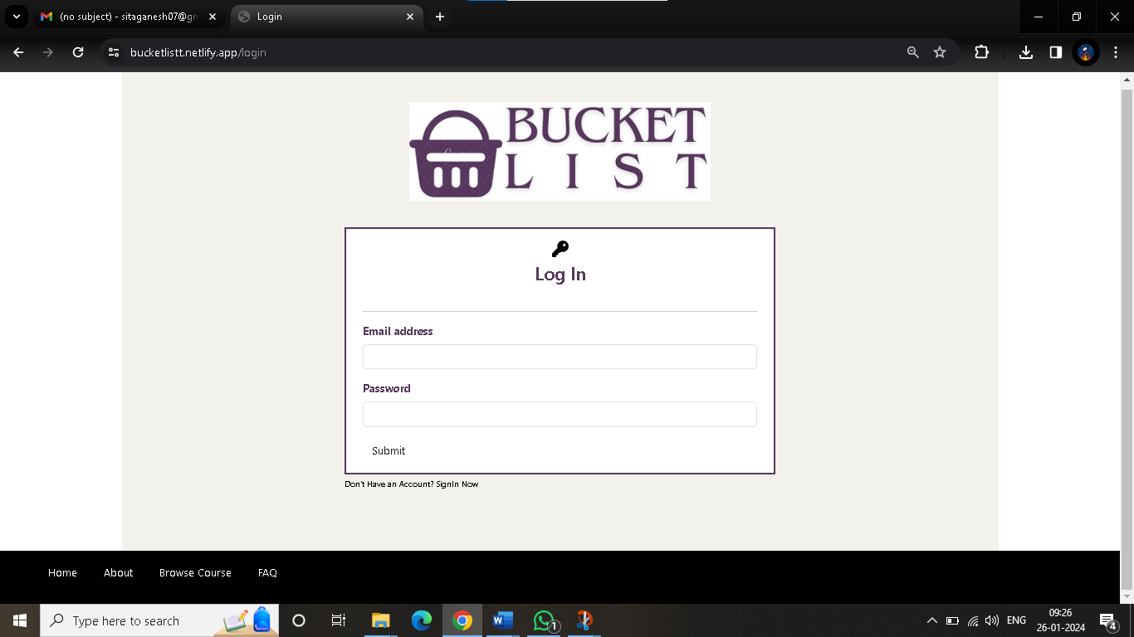

### 2. integration testing :

Integration testing checks the interaction and integration between different components or modules to ensure they work together.

#### about-page integration testing :

|  |  |  |  |
| --- | --- | --- | --- |
| **s.no** | **Test Description** | **Expected Result** | **Success** |
| 1. | validate integration between navigation and info | smooth navigation while accessing detailed info | success |
| 2. | test overall integration of about page | all components work seamlessly  together | success |

|  |  |  |  |
| --- | --- | --- | --- |
| **s.no** | **Test Description** | **Expected Result** | **Success** |
| 1. | validate integration between course details and navigation | smooth navbar while accessing course details | success |
| 2. | check integration of course reservation functionality | redirect to external website for enrollment | success |

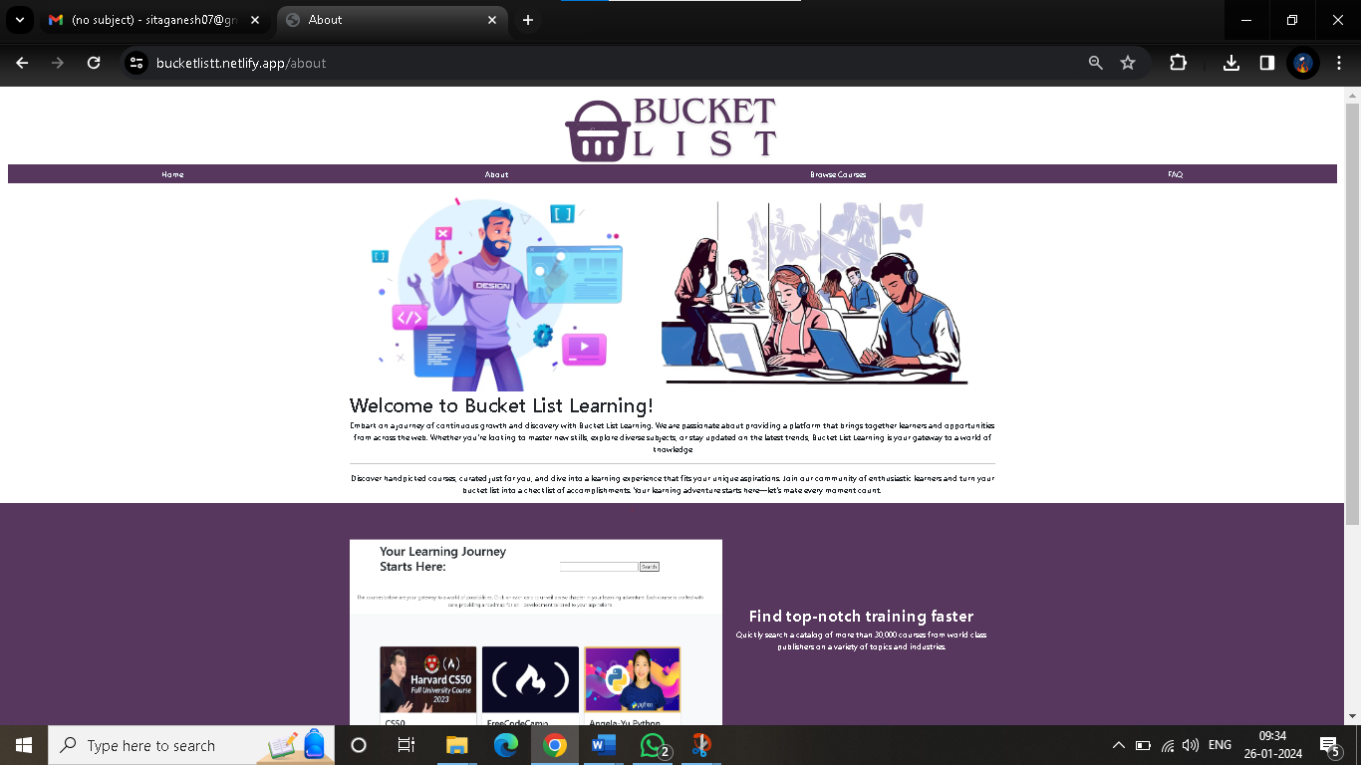

#### course-page integration test :

#### 

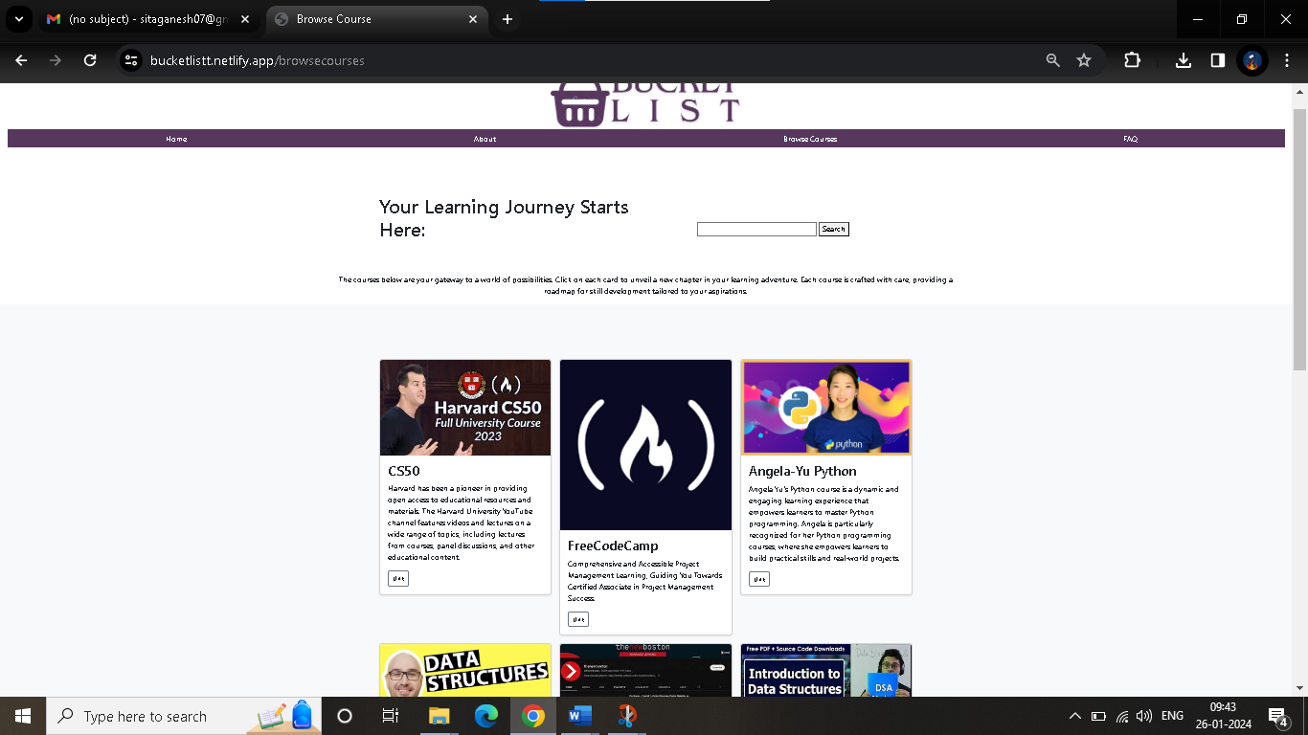

### 3. Black box Testing :

Black-box testing focuses on assessing the functionality of the software without knowledge of its internal code. For our online course reservation. Evaluates the layout, design, and user interactions with the search bar. Login Page Black-Box Testing: Examines user interactions with the login form.

|  |  |  |  |
| --- | --- | --- | --- |
| **s.no** | **Test Description** | **Expected Result** | **Success** |
| 1. | test home page layout and design | layout is visually appealing and user-friendly | success |
| 2. | test user interaction with search bar | accurate search result displayed | success |

### 4. White box Testing :

White-box testing, also known as structural or glass-box testing, examines the internal logic and code of the software.

* For our online course reservation. Analyzes code paths for displaying detailed information. Code for handling course details, reservation requests

|  |  |  |  |
| --- | --- | --- | --- |
| **s.no** | **Test Description** | **Expected Result** | **Success** |
| 1. | verify backend code for handling login requests | successful login request are processed by backend | success |
| 2. | test code paths for validating username and password fields | proper validate logic is implemented | success |
| 3. | verifies backend code for handling course details requests | accurate course details are retrieved  from backend | success |

# Conclusion:

In closing, this Software Requirement Specification (SRS) articulates the fundamental requirements and vision of Bucket List website. By delinearting user need, software functionalities, and technical specifications, this document serves as a compass for the development person. The Bucket list website aspires to be a user-friendly hub for learning, facilitating seamless course discovery and management.